RITA REMINDER TO UPDATE DEDNAM 2018
Districts need to verify every city tax deduction code in DEDNAM (USPSDAT/DEDNAM).
Tax Codes may be found at:
R.I.T.A http://www.rita.to/resources/tax-rates-tables/
When a Deduction is a R.I.T.A. entity:

W2 Abbrev (6 characters long)
Verify the naming convention is what you want showing on the W-2.
Tax Entity Code
Field must be populated. For districts who had this information in the system prior to the release, this information was automatically inserted and you may leave it as is. If the field is blank, it is recommended to use the three digit tax code provided by R.I.T.A.
R.I.T.A. Code
Using the three digit codes provided by R.I.T.A., verify/insert this information.
Single Character field
If the entity is R.I.T.A this field must contain a “Y”
Blank Line Fields below the R.I.T.A. code
If your district had this information filled in prior to the release, it populated on it’s own. If it is blank, the naming convention used in the W2 Abbrev. field will be used when running W2PROC. It is recommended to update both description fields.

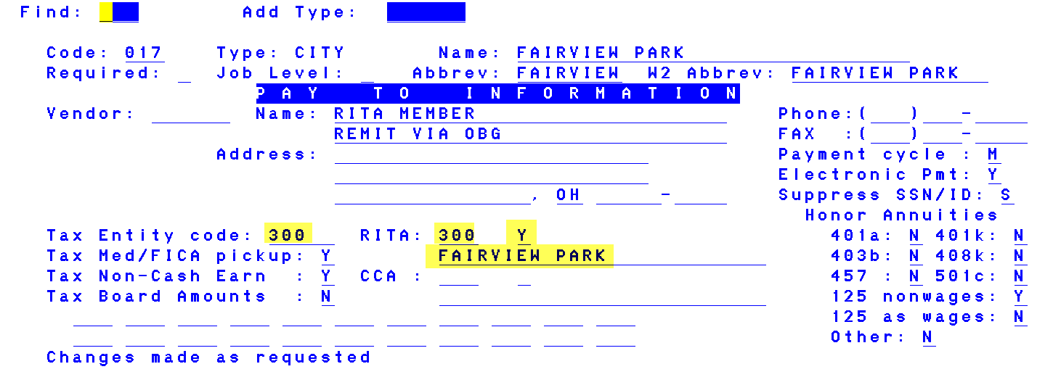

When a Deduction is NOT a R.I.T.A. entity:
If your district will be reporting electronically to the Municipality:

W2 Abbrev (6 characters long)
Verify the naming convention is what you want showing on the W-2.
Tax Entity Code
Field must be populated. Contact Municipality for entity code
R.I.T.A. Code
Field should be blank (three digit field)
Single Character field
Flag may be left Blank or “N” (F7 for help)
Blank Line Fields below the R.I.T.A. code
It is recommended to update both fields with the cities full name. If not entered, the naming convention from the W2 Abbrev field should be pulled when running the W2PROC.

